RECEIPT AND INVOICE DIGITIZER
A Smart System for Receipt and Invoice Text Extraction
January 13, 2026
HARINI KAVETI
harinikaveti2003@gmail.com

CONTENTS

- Title Page
- Contents Page
- Problem Statement
- Modules
- Architecture Diagram
- Process Flow
- Database
- Validation
- Output
- Conclusion
- References

MILESTONE – 1 PROBLEM STATEMENT

In many organizations and for individuals, receipts and invoices are still handled in paper form. These paper documents are easily lost, damaged, or incorrectly entered into systems when done manually. Manual data entry also consumes time and may lead to errors in financial records.
The goal of this project is to build an automated system that can scan receipts and invoices, extract text using OCR (Optical Character Recognition), and convert them into digital records.

Milestone 1 focuses on:
- Uploading receipt/invoice files
- Preprocessing images for better OCR accuracy
- Extracting raw text from receipts and invoices

MODULE DESCRIPTION AND OBJECTIVES

2.1 Document Ingestion Module
Objective: To allow users to upload receipt or invoice files into the system.
Description: This module enables users to upload documents in image or PDF format. The system supports common formats such as JPG, PNG, and multi-page PDF files. Uploaded PDFs are converted into images so they can be processed further.
Key Functions:
- File upload using web interface
- Support for image and PDF formats
- Conversion of PDF pages into images

2.2 Image Preprocessing Module
Objective: To enhance image quality and improve OCR accuracy.
Description: Before performing OCR, uploaded images are pre processed to remove noise and improve text clarity. This step is important because raw images may contain shadows, blur, or poor contrast.
Key Functions:
- Conversion of images to grayscale
- Contrast enhancement using CLAHE
- Noise removal using Gaussian blur

2.3 OCR and Raw Text Extraction Module
Objective: To extract readable text from processed images.
Description: This module uses Tesseract OCR to read text from cleaned receipt and invoice images. The extracted text is returned as raw text, which is later used for field extraction in further milestones.
Key Functions:
- OCR processing using Tesseract
- Extraction of raw text from images
- Handling of multi-page documents

TECHNOLOGIES USED

Technology | Description
Python | Main programming language used for implementing the project
Stream lit | Web-based user interface for uploading receipts and displaying results
OpenCV | Image preprocessing such as grayscale conversion and noise reduction
PIL (Pillow) | Image handling and format conversion
Tesseract OCR | Text extraction from receipt and invoice images
PDF2Image | Conversion of PDF files into images for OCR processing
SQLite | Local database storage (initial setup for future milestones)

SYSTEM DESIGN

The user interface is developed using Stream lit. The application includes:
- Sidebar for vault management
- File upload section for receipts and invoices
- Display of original and pre-processed images
- Button to process and save extracted data
The design is simple and user-friendly, suitable for non-technical users.

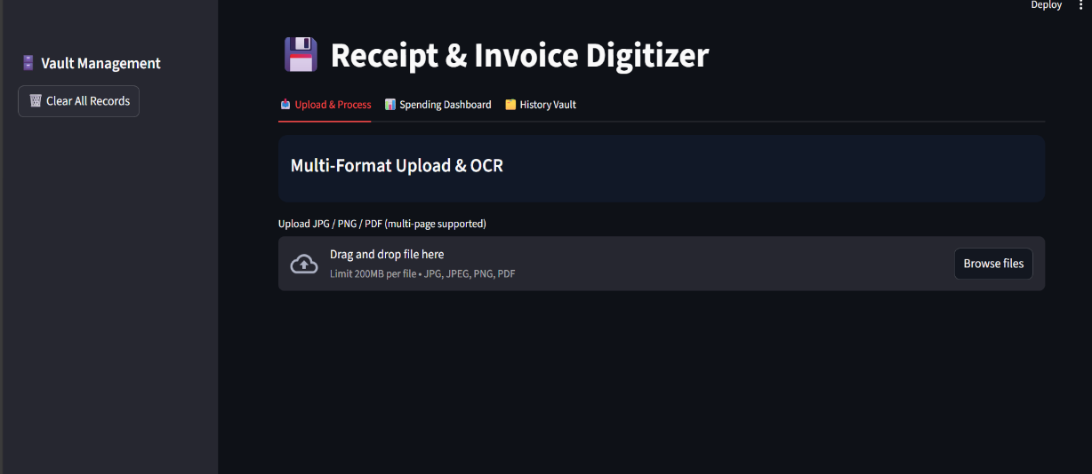

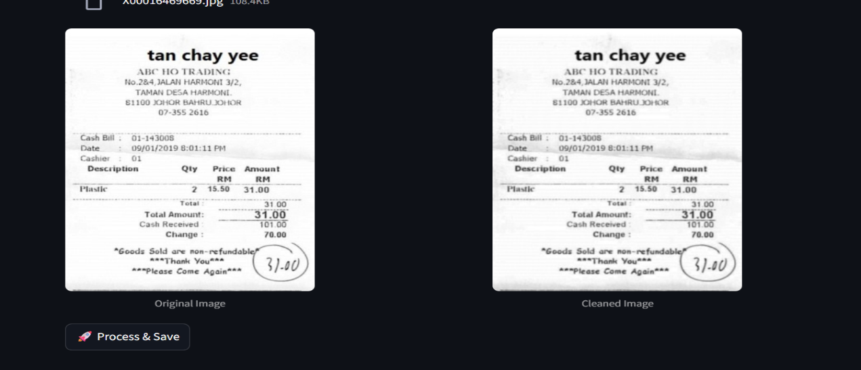

ARCHITECTURAL DESIGN
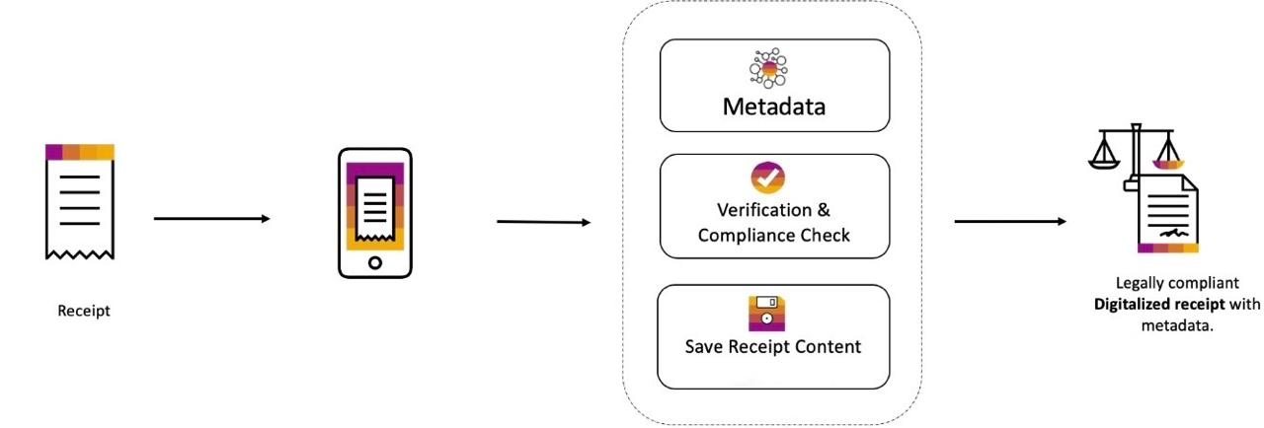

6. PROCESS FLOW
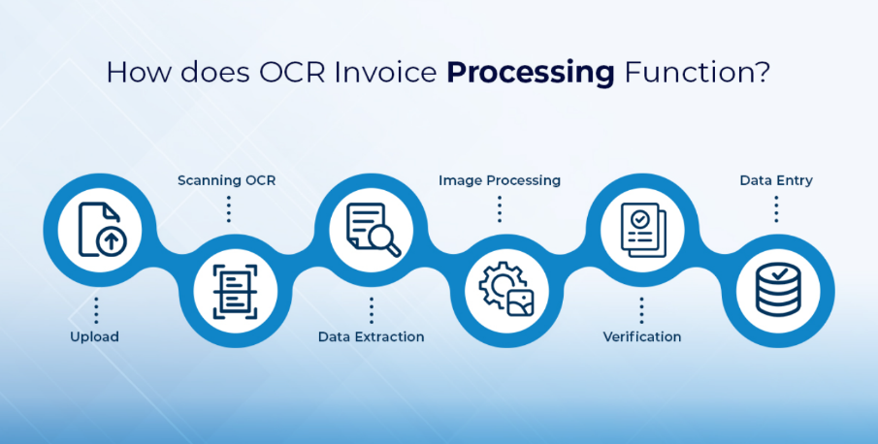

7. DATABASE SCHEMA

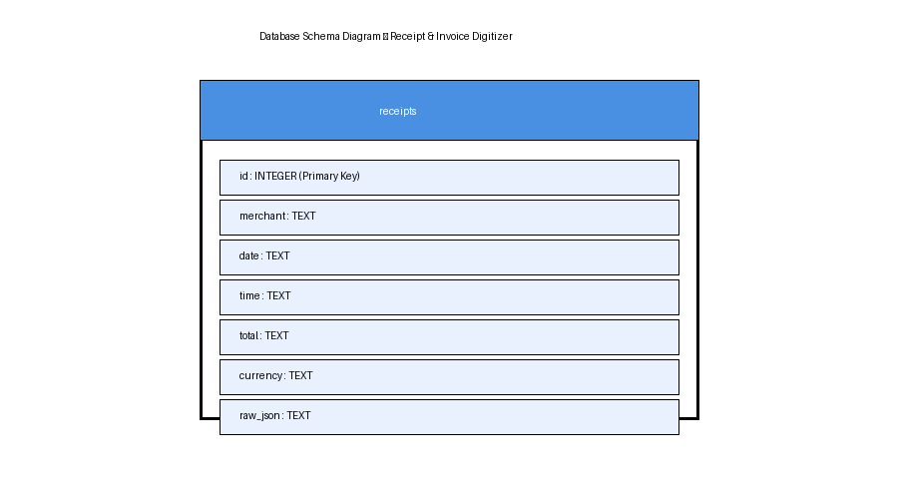

8. VALIDATION LOGIC

8.1 Total Amount Detection
- Regular expressions are used to detect keywords like "total" or "amount"
- Numeric values following these keywords are extracted

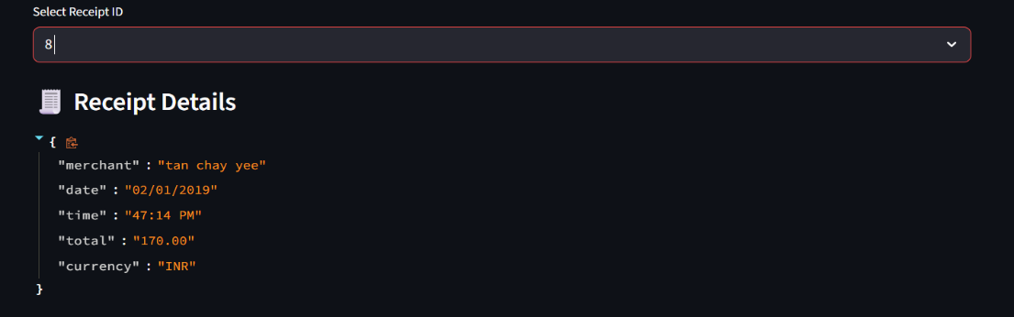

8.2 Duplicate Detection
- The system checks merchant name, date, and total amount
- If a record already exists, the receipt is marked as duplicate

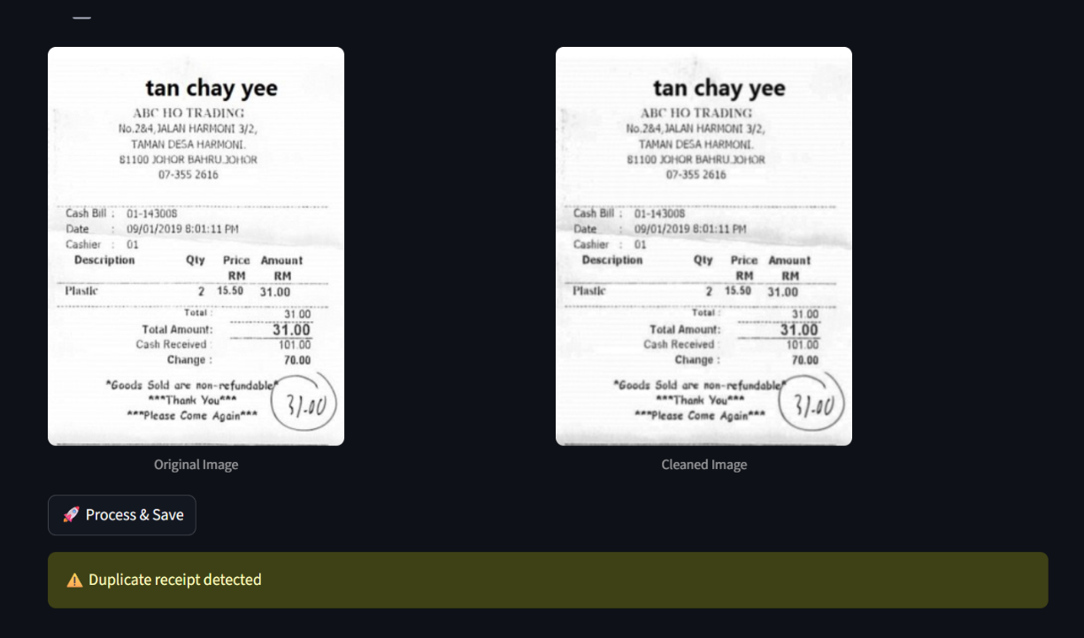

9. OUTPUT

Outputs include:
- Cleaned receipt image
- Extracted raw text
- JSON data:
- merchant
- date
- total
- currency
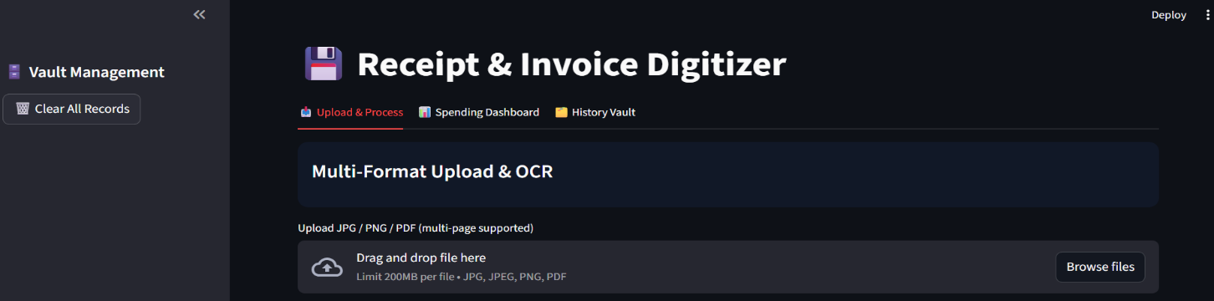

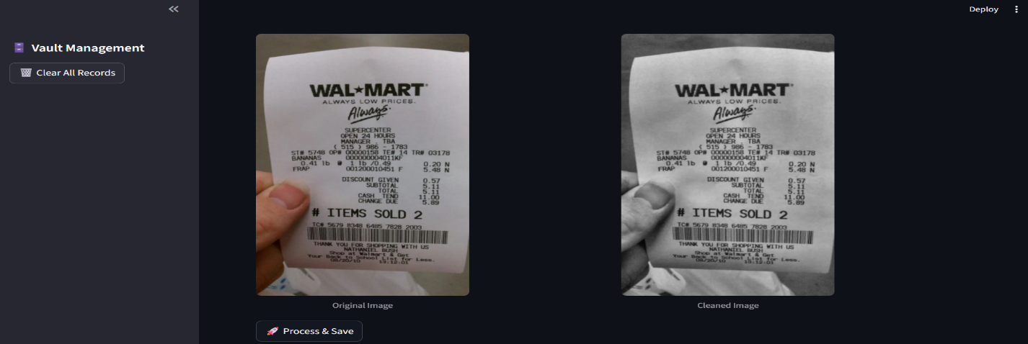

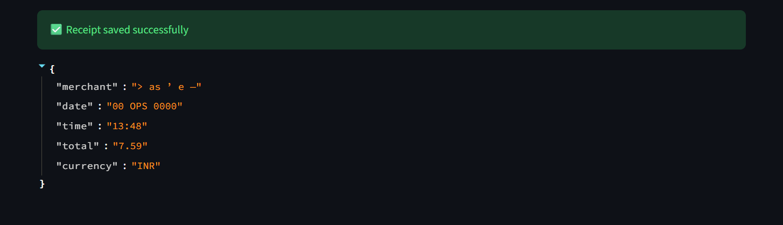

10. CONCLUSION

Milestone 1 focused on image preprocessing and text extraction from receipt and invoice images. Using OpenCV and PIL, the uploaded images were enhanced to improve OCR accuracy. Tesseract OCR was then used to extract raw text from both image and PDF files.
This milestone successfully converted receipt images into readable text, providing the base input required for further data processing. The completion of Milestone 1 laid a strong foundation for field extraction, validation, and database storage in the next milestone.

